**Video game short-list**

1. Tetris
2. Skies Ablaze
3. Goat Afloat
4. Tetris:

A one or two player game where the player turns various shaped blocks which constantly drop from the top of the play area, fall at a given pace (based on difficulty level), and then lock in to place when they hit the bottom of the play area, or make contact with another block already in position. The user can eliminate blocks if they can make them be continuously adjacent from the left side to the right, all on a single level. Points are awarded for blocks dropped, and for block elimination. The two player version would be a sequential game where one player would go first, then the other would go second. The scores would then be compared between the two.

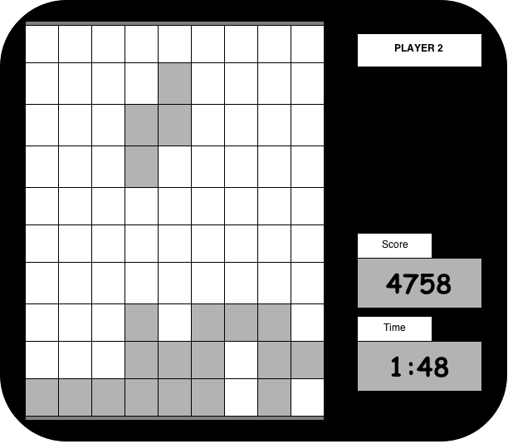

1. Skies Ablaze:

This game will be a survival game, rocks will fall from the sky (being thrown by a dragon) the player must avoid the rocks and attempt to fire at them with the ship’s cannon. After a given time, if the player is still alive, the dragon will appear and float across the screen to wreak havoc on the ship. The fireballs that will be falling cannot be blown up like the boulders and must be avoided. If the player can manage to destroy the dragon while avoiding the bombs, a score multiplier will be factored into their score. The boat will take damage to its energy for each rock that hits the water, and more if it hits the ship. A Two player version will have each player play one after another. Difficulty levels could be added to increase the difficulty.

http://www.ferryhalim.com/orisinal/g2/voyage.htm

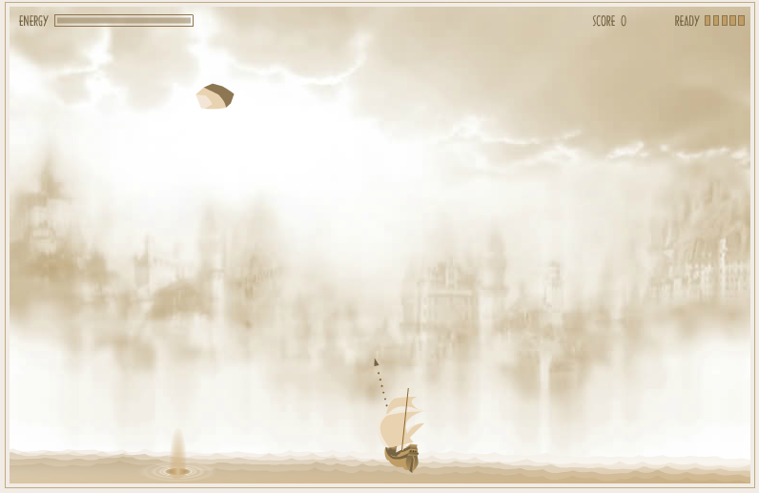

1. Goat Afloat:

An adaptation of the game “flappy bird”. The user uses only the space button. The space button will act as a “float upwards” command, whereas not using it will cause the goat to float downwards. Randomly generated walls protruding from the top and bottom will appear as the goat will be moving at a constant rate from left to right. Points are awarded based on distance travelled. The two player version would be a sequential system where one player would go, then the other would follow. Then, their scores would be compared to determine a winner. For comedic value, the player character could be a drunken goat passed out in a boat – your goal is to get the boat to go as far as possible without the goat waking up!

